Rubik's 3x3x3 Cube
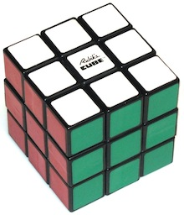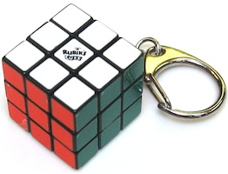
Patent filed by Erno Rubik 1975, sold by Ideal Toys in the 1980's.
(plastic with colored stickers, 2.2"; keychain 1.2")
The first puzzle of this type in a large class of puzzles in the years to follow. Challenging and fun to play with. One can rest at any time and pick it up later. A number of ways to construct this puzzle have been devised over the years; here are the pieces of an original Rubik's Cube like shown above, where there is a central axis assembly and 20 pieces that interlock with it.
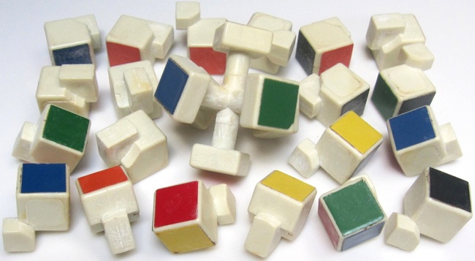
Rubik 3x3x3 Six Step Solution
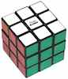 | Notation: L (left), R (right), F (front), B (back), U (up), D (down) for 90 degree clockwise rotation of that face; - means counterclockwise and a 2 means do it twice. Corners are named with three letters and edges are named with two letters (e.g., FR means looking at the front, it is the edge on the right).
1. Solve the top layer (including its sides) and turn the cube over so now it becomes the solved bottom layer (easy with a little practice).
2. Solve the middle layer:
Rotate the middle so centers are correct, and then move edges between the up and middle layers until the middle is solved. If an edge first needs to be flipped, move it be FU and do the edge flipper of Step 3 (the edge gets flipped, and now rotate the top to move it back to be FU). Parentheses are just to make the sequence easier to read.
edge mover, FU -> FR: (U R) (U- R-) (U- F-) (U F)
3. Flip the up edges so they all have the correct color on top:
If no up edges have correct top color, first do the edge flipper. Now position the cube so UL has correct top color and UF does not, and do the edge flipper once or twice.
edge flipper: F (R U) (R- U-) F-
4. Move the up layer edges to their correct positions:
As needed, re-position the cube and do the edge swapper.
edge swapper, UF<->UL: (R U) (R- U) (R U²) (R- U)
5. Position the up layer corners:
The corner cycle leaves UFR alone and cycles the other three counterclockwise. Identify one corner that is correct (but may be rotated), or if there is not one, do the corner cycle. Then re-position the cube so UFR is correct, and then corner cycle once or twice:
corner cycle: (U R) (U- L- ) (U R-) (U- L)
6. Rotate the up layer corners (read this whole step before starting it):
*** Don't worry that the bottom is mixed up as you do this, it will be ok in the end.
Position the cube so UFR is not correct and repeat steps A and B until all corners correct:
A. Repeat the corner rotator until the UFR corner is correct:
corner rotator: R- D- R D
B. Rotate the up layer (not the whole cube) so that UFR is incorrect.
Remembering The Basic Rubik 3x3x3 Six Step Solution
Each sequence has a natural rhythm, but an easy mistake is to start off wrong. The Edge Mover and Corner Cycle start with U, the Edge Flipper (after parking the F) and the Edge Swapper start with R. To avoid forgetting your place, run the sequence in your head, and when you get faster, simply count 1,2,3,4,... as you go; 8 for the edge mover, edge swapper, and corner cycle; 4 between the F's of the edge flipper; 2 sets of 4 for the corner rotator.
Edge Mover (for Step 2):
edge mover, FU -> FR: (U R) (U- R-) (U- F-) (U F)
It starts with a U, and every other move involves a U or U-.
First two moves and last two moves are clockwise, middle four moves are counter clockwise.
First 4 moves involve R, second 4 moves involve F.
Edge Flipper (for Steps 2 and 3):
edge flipper: F (R U) (R- U-) F-
"Park" the front with F, do (RU) (R-U), and then "unpark" the front with F-.
Edge Swapper (for Step 4):
edge swapper, UF<->UL: (R U) (R- U) (R U²) (R- U)
It's R R- R R- interleaved with U U U² U.
The R's alternate + and -, and the U's keep going clockwise, where the third is 180 degrees.
Corner Cycle (for Step 5):
corner cycle: (U R) (U- L- ) (U R-) (U- L)
It's U U- U U- interleaved with R L- R- L.
Corner Rotator (for Step 6):
corner rotator: R- D- R D
Always complete this sequence before doing Step 6B; it is easy to forget the final D when you see the correct color on top.
It will be done twice (eight moves to rotate once) or 4 times (16 moves to rotate twice).
Speeding Up the Basic Rubik 3x3x3 Six Step Solution
Step 1: After getting faster at the other steps, this step can become the slowest. Starting at one corner and working across the top works, but at each step one is hunting for one or two specific pieces to place next, and that can be slow. A faster approach may be to pick a middle piece, say white, and start with it on top. Then repeatedly look for the first white edge you can find and place it. Then repeatedly look for the first white corner you can find and place it. Although not necessary once you get fast, it can help to keep the middle layer aligned so each time you find a piece it is easy to see where it needs to go.
Step 2: Instead of using the edge flipper, learn the symmetric sequence that moves an edge down counterclockwise from up to middle:
edge cc-mover, UF -> FL: (U- L-) (U L) (U F) (U- F-)
Or, use these two more complicated sequences that use only 7 moves:
alternate edge mover, FU -> FR: (L F²) U F U- (F² L-)
alternate edge cc-mover, UF -> FL: (R- F²) U- F- U (F² R)
Step 3: Before the final F-, if the right side of FR is not the top color, instead of wasting time to do F- F, repeat the (R U) (R- U-) before doing F-.
Step 4: If position of the top layer leaves only two adjacent edges to be exchanged, start with UF correct and do the first 7 edge swapper steps, which leaves UF unchanged and cycles the other three counterclockwise, or use the reverse sequence, shown below, to cycle them clockwise. For the case that UF and UB are correct and UL and UR are exchanged, cycling either way will leave just two adjacent edges to be fixed with a normal edge swapper.
clockwise cycle UL, UB, UR: R (U² R-) (U- R) (U- R-)
Step 5: If no corners are correct, learn how to tell for which orientation of the cube the corner cycle will leave things so that a counterclockwise cycle will be needed. Or, if you have identified a correct corner and a clockwise cycle of the other three is needed, instead of doing the corner cycle twice (three times returns the cube to where it was), save time by reversing the sequence:
reverse corner cycle: (L- U) (R U- ) (L U) (R- U-)
Step 6: Every iteration of the corner rotator exchanges UFR and DFR, and repeating it 6 times returns the cube to where it was. Step 6A will use the corner rotator 2 times if the top color is on the right side of the UFR corner, or 4 times if it is on the front, in which case it is faster to do the reverse sequence 2 times (easy, start with D- instead of R- and everything follows):
reverse corner rotator: D- R- D R
The Corner Rotator - Why Step 6 Works
Step 6 is the same as Step 3 of the solution presented for Rubik's 2x2x2, and we repeat here the observations from that page:
• Step 6A affects only 4 corners by exchanging two front right corners and also exchanging the two back down corners.
• Doing Step 6A twice leaves corners in the same positions, except those four corners are rotated, and doing Step 6A six times leaves the corners the same as when you started.
• On the up layer Step 6 only modifies the front right corner.
• Since Step 6 started with the down corners correct, once three of the four up corners have been fixed, fixing the fourth up corner must leave the down layer correct. This is because when at every 6th move the two back down corners are correct, all that is left that could be incorrect are the two front right corners, but due to parity considerations, a completely solved puzzle except for two adjacent rotated corners is not possible (however, although not hard to overcome, this is not true for the Rubik 3x3x3 Void Cube).
• The only edge pieces that are affected are FR, RD, BD, which are on the lower two layers; they return back to where they were after 6 moves.
Fun With The Corner Rotator
It is interesting to see that the Corner Rotator can be used for Step 5, by memorizing two "do simple nothing" sequences:
5 (alternate). Position the up layer corners:
Let S be the sequence of Step 6A, and let Z be the sequence S S S- S- (which does nothing) interleaved with rotating the up layer 360 degrees with U U U²:
alternate corner cycle: Z = S U S U S- U² S-
Z does a counterclockwise cycle of UFR, UBR, UBL; repeat it until at least one up corner is correct (but may be rotated), re-position the cube so this corner is UFL, and then continue repeating it until all up corners are in their correct positions.
Although this sequence is relatively long after expanding each S to the corresponding four moves, it is relatively easy to remember as the interleaving of two do-nothing sequences. In addition, if you forget what it does, a pencil and paper can be used to draw what happens to the up layer; see the explanation and diagrams presented for the Rubik's 2x2x2 alternate solution.
Solving Rubik's 2x2x2 With 3x3x3 Sequences
Recall the corner cycle sequence of step 5 of the six step solution):
corner cycle: (U R) (U- L- ) (U R-) (U- L)
It's U U- U U- interleaved with R L- R- L.
A completely solved 3x3x3 cube except for two adjacent corners exchanged is not possible due to parity considerations; that is, if just two adjacent corners are interchanged, then it must be that the edges are not completely solved. This is possible for the Rubik's 2x2x2 cube, but the corner cycle sequence can still be used because there are no edge pieces to be disturbed.
Here is a simple algorithm:
Rotate the top layer to see if there is a cube that can be placed in its proper position while leaving the other three to be fixed using the corner cycle; if so, all set.
Otherwise, rotate the top layer so that UFL and UFR need to be exchanged, and do the corner cycle sequence:
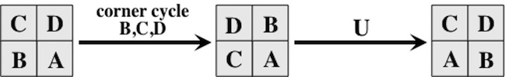
It could be that UBL and UBR also have to be exchanged, in which, after fixing UFL and UFR, rotate the top 180 degrees and repeat the above sequence to exchange them.

A Corners-First Rubik's 3x3x3 Solution
*** Don't bother with this until you are good at the standard 3-step solution.
Here is a different approach that starts with solving the corners, then the top and bottom edges, and finally the middle edges.
Notation: L (left), R (right), F (front), B (back), U (up), D (down) for 90 degree clockwise rotation of that face; a – means counterclockwise and a 2 means do it twice. Corners are named with three letters and edges are named with two letters (e.g., FR means looking at the front, it is the edge on the right).
1. Solve the corners using a solution for Rubik's 2x2x2.
2. Position up and down edges by moving to and from the middle layer:
A. Cycle edges between the middle and up layers to get three up edges correct:
RB -> FU, FU -> FD, FD -> RB: F M F-
That is, repeatedly position the cube so that the edge to be moved is RB, rotate the U layer so that where you want to move it to is FU, and cycle.
B. Turn the cube over, and repeat Step A.
C. Move the edge that goes to FD to the FU position; then move final edge to FU.
3. Use this to flip up and down edges (parentheses are just to make the sequence easier to read):
Flip the UF edge: F- M (F M)² F-
4. Use rotations of the middle layer and these sequences to position middle edges:
Front back swap, LF <-> LB, RF <-> RB: (R² M²)²
Clockwise cycle, RF -> LB -> RB -> RF: (R² M) (R² M-)
Although not necessary, these can save time:
Diagonals swap, LF<->RB, RF<->LB: M L² R² M- L² R²
Counter clockwise cycle, RF -> RB -> LB -> RF: (M- R²) (M R²)
5. Use this to flip middle edges (for right to left diagonal, do B² before and after):
Flip RF and RB: (R M-)³ R M² R (M- R)³
Although not necessary, this can save time:
Flip RF and LB: (R M-)³ (R M) (R M-)³ (R M)

An Edges-First Rubik's 3x3x3 Solution
*** Don't bother with this until you are good at the standard 3-step solution; the same notation is used here.
It is interesting that the corner cycle and corner rotator operations from the standard 3-step layer by layer solution can be used for an edges first approach to solving. The sequence
S = U- R U R-
rotates the three edges around the upper right by doing:
UF -> UR, UR -> FR, FR -> UF
It leaves the UF and UR edges in the same flip orientation, and flips the flips the FR edge when it moves up. It has the side effect of permuting the UFL, UFR, UBR corners, but that won't matter because here we will be solving corners last.
Given S, here is an outline of an edges-first approach to solving:
1. Solve the top layer edges, and turn the cube over (easy with a little practice).
2. Solve the middle layer:
Rotate the middle so centers are correct, and then use S to place each of the edges. S can be used to move an edge up to the top to then go to a different middle position. Also, if an edge needs to be flipped before placing it, rotate the up layer and position the cube so you want to move UB to RB with a flip, and do S in reverse:
T = R- U R U-
3. Solve the top edges:
S can be used to permute edges; for example:
S U- S U- does the cycle UF -> UL -> UB -> UF
If some edges need to be flipped, some clever playing around with S and T should work.
4. Position the corners:
First, use the corner cycle operation to get the correct corners on the top and bottom (by temporarily positioning a side face to be up), then use it on the up and down faces.
5. Rotate the corners:
Use the corner rotator operation to finish the up and down faces.
Rubik's 3x3x3 Cube - 15 Years Later
In time, for smoother operation, cubes were sold with redesigned central axes and adjustable springs in the centers; here is an example:

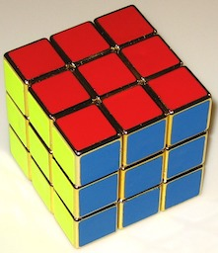
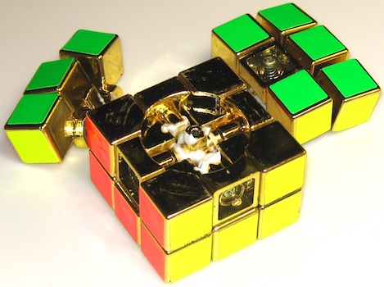
Rubik's 3x3x3 Cube - 25 Years Later
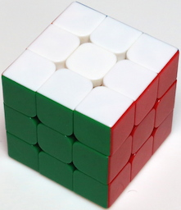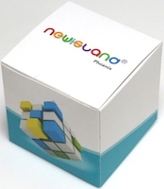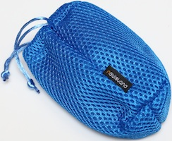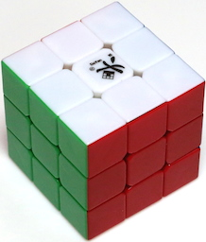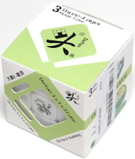
Plastic, stickerless, made in China, purchased from Amazon.com in 2015.
(left: Newisland, sold by YaMiYo, comes in a with a storage bag, 3.25" square;
right: DaYan, sold by Maxin, comes in a fitted box, 2.3" square)
In the early 2000's, smoother working versions of Rubik's 3x3x3 were widely available, with screws / springs for adjustable tension and smooth turning even when layers are not exactly aligned (beveled interior corners in conjunction with the spring action give a minimal degree of automatic alignment). The Newisland cube shown above was a gift from a friend; it is smooth and quiet, comes with a storage bag and directions, and its literature explains PA plastic lower resistance, anti-popping, and internal construction. The less expensive Da Yan cube shown above has different but similar construction; here are photos of it apart:
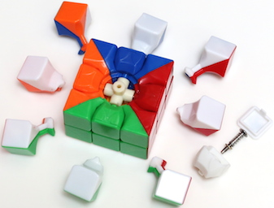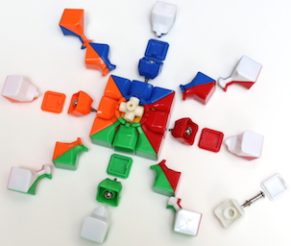
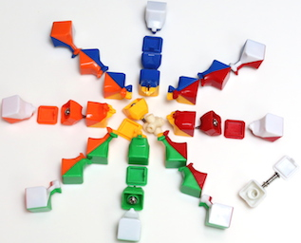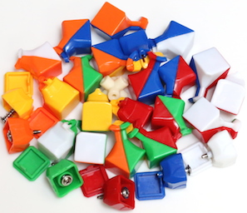
Rubik 3x3x3 Designer Cubes
Here are two examples of more expensive cubes advertised for speed cubing.
In addition to complex mechanisms that include screws and springs, the Valk cube shown on the left below has magnets to give a slight click stop effect. The GANs cube on the right below has a similar weight and smooth action as the Valk, but with no magnets.
Both are beautiful cubes that are pleasurable to use, even if you are not speed cubing.
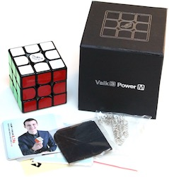  "Valk 3", designed by Mats Valk,  purchased from Amazon.com 2017.  (plastic, 2+3/16" square;  3.75" square box with a magnetic lid  and extra stickers and springs) | 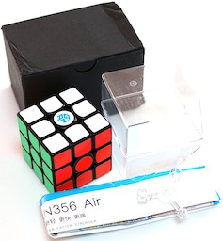  "GANS 356 Air Advanced",  purchased from Amazon.com 2018.  (plastic, 2+3/16" square;  with display box and nut tool,  and 4 pages of instructions)

Rubik 3x3x3 With No Center Assembly
The original Rubik cube as well as modern versions are all based on a center spindle assembly that connects the six center squares and holds the whole cube together where the other pieces flow around it.
The Rubik 3x3x3 Void Cube is based on a completely different idea. There are no centers (one can pass their finger through the cube in all three directions).
The Rubik 3x3x3 Edges Only Cube (a.k.a. cornerless void cube) uses the same mechanism and eliminates the corner pieces as well.
A (Physically) Large Rubik Cube
One way to measure larges is the dimension of the cube; for example cubes of size 33x33x33 have been made. But another measure is the physical size of the cube. This cube, made by Tony Fisher, is 1.57 meters (over 5 feet) tall:
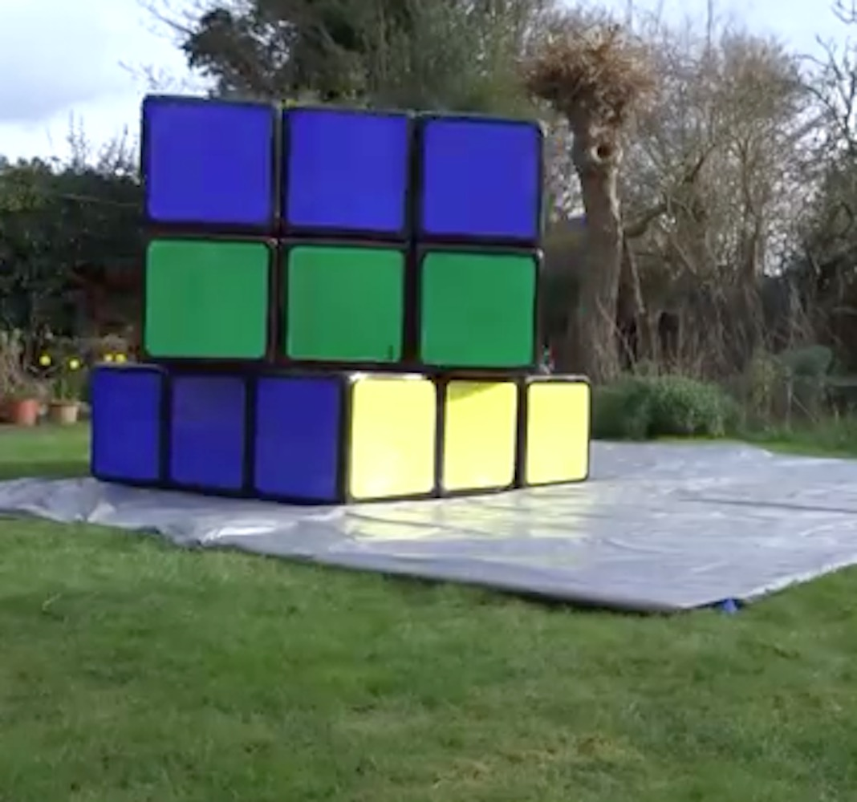
(see https://www.youtube.com/watch?v=SkwlRTX2ecA)

Rubik's 3x3x3 Other Versions
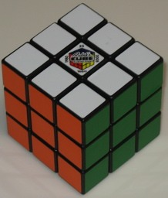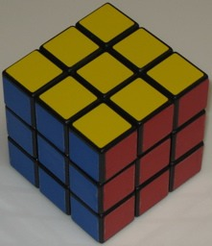  25th Anniversary Cube, 2.2" | 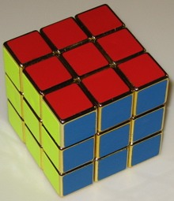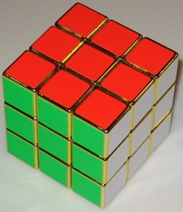  Gold Cube, 2.2"
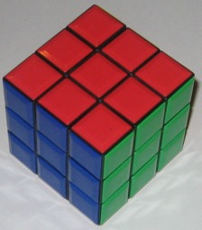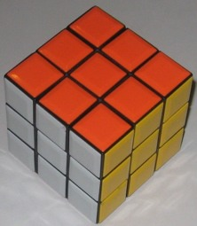  all plastic with no stickers, 2.2" | 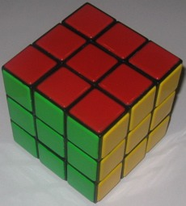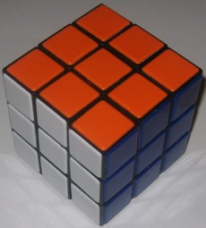  large all plastic with no stickers, 3.5"
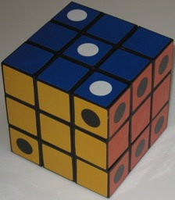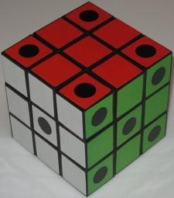  Large Dice Cube, 3.5" | 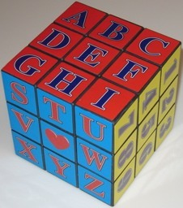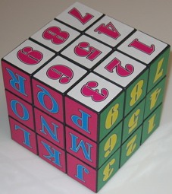  Large Alphabet Cube, 3.5"
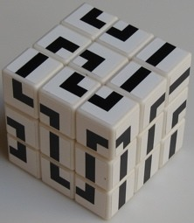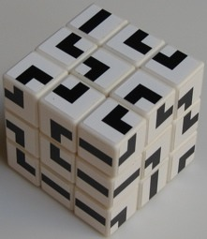  White Maze Cube, 2.2" | 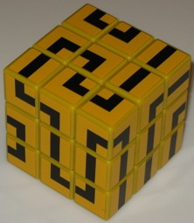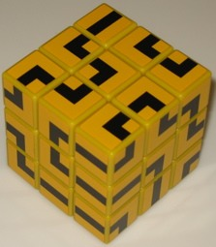  Yellow Maze Cube, 2.2"
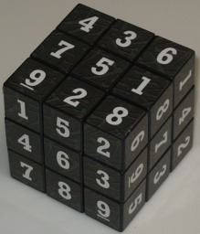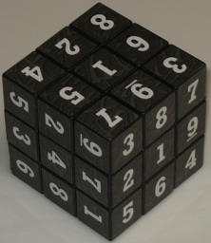  Sudoku Cube, 2.2" | 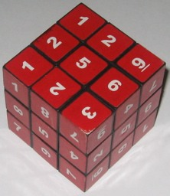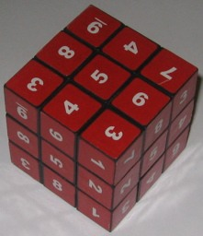  Red Sudoku Cube, 2.2"
Rubik's 3x3x3 Other Versions Continued
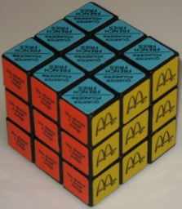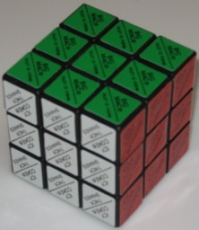  McDonalds, 2.2" | 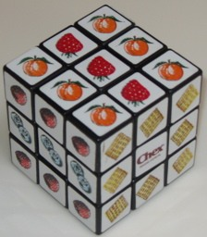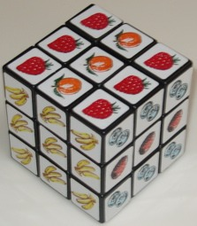  Chex Cereal, 2.2"
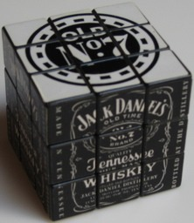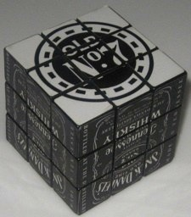  Jack Daniels, 2.2" | 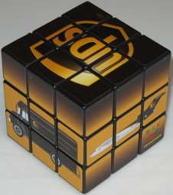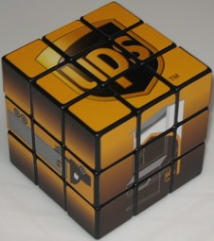  UPS, 2.2"
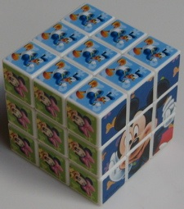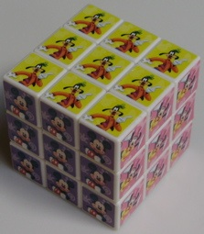  Mickey Mouse, 2.2" | 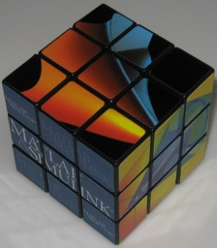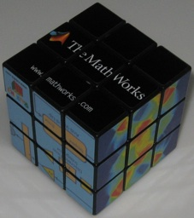  MatLab, 2.2"
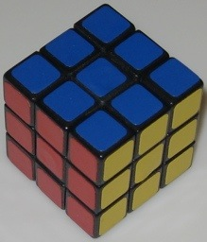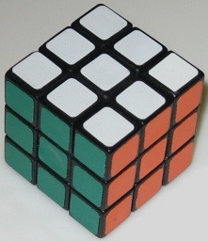  Small Cube, 1.2" | 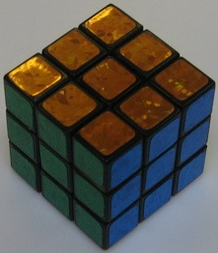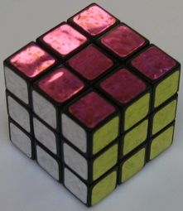  Small Shiny Cube, 1.2"
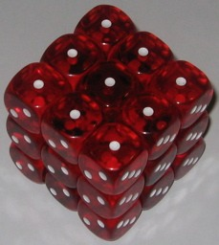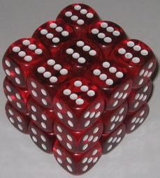  Dice, 2.2" | 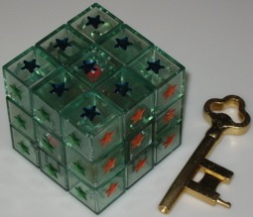  Assembly Cube, 2.2"
Some Other Rubik 3x3x3 Solutions (In Alphabetical Order)
Beust's Page, from: http://beust.com/rubik
Bieber's Page, from: http://www.ronaldbieber.de/Fun/Rubik
Chess And Poker Page, from: http://www.chessandpoker.com/rubiks-cube-solution.html
Cheyer's Page, from: http://www.ai.sri.com/~cheyer/rubiks/rubiks.html
Dedmore's Page, from: http://www.helm.lu/cube/solutions/rubikscube
Dry Erase Board Page, from: http://www.thedryeraseboard.com
Fridrich's Page, from: http://ws2.binghamton.edu/fridrich/cube.html
Jaap's Page, from: http://www.geocities.com/jaapsch/puzzles/cube3.htm
Jasmine Page, from: http://peter.stillhq.com/jasmine/rubikscubesolution.html
Jeays' Page, from: http://jeays.net/rubiks.htm
Juergen's Page, from: http://www.mathematische-basteleien.de
Marshall's Page, from: http://helm.lu/cube/MarshallPhilipp
McFarren's Page, from: http://www.geocities.com/abcmcfarren/math/rc/RubCub0.htm
Monroe's Page, from: http://www.alchemistmatt.com/cube/rubik.html
Nerd Paradise Page, from: http://www.nerdparadise.com/puzzles/333
Olefsky Puzzle Solver Page, from: http://www.puzzlesolver.com
Ortega and Jelinek Corners First Solution Page, from: http://rubikscube.info/ortega.php
Oxford ComLab Text Solution, from: ftp.comlab.ox.ac.uk
Petrus' Page, from: http://lar5.com/cube
Rob's Rubik Repair Page, from: http://www.roobik.com/cgi-bin/rubix/rubix.cgi
Rubiks.com Solution, from: http://www.rubiks.com
Scared Cat Page, from: http://www.scaredcat.demon.co.uk/rubikscube/the_solution.html
Shengshou Speed Cube Solution, from: http://www.speedsolving.com/wiki/index.php/Shengshou
Shon's Rubik's Place Page, from: http://www.rubiksplace.com
Still's Page, from: http://peter.stillhq.com/jasmine/rubikscubesolution.html
V-Cube Page, from: https://www.v-cubes.com/v-cube-world/v-cube-news/how-to-solve-the-v-cube-3
You Rubik Page, from: http://www.yourubik.com
WikiHow Page, from: http://www.wikihow.com/Solve-a-Rubik's-Cube-(Easy-Move-Notation)
Some Rubik 3x3x3 Patents
Rubik U.S. Patent, from: www.uspto.gov - patent no. 4,378,116
Rubik Hungarian Patent, BE887,875.
Sugden Patent, from: www.uspto.gov - patent no. 6,974,130
Sugden Design Patent, from: www.uspto.gov - patent no. D495,378
Scott Patent Application, from: www.uspto.gov - application no. 2010/0230897

Further Reading
God's Number is 20, from: http://www.cube20.org
Kociemba's Two Phase Algorithm and Cube Mathematics, from: http://kociemba.org/cube.htm
22 Moves, from: http://www.springerlink.com/content/q088143tn805k124/fulltext.pdf
Speed Solving Page, from: http://www.speedsolving.com/wiki/index.php/Main_Page
Superflip, from: http://www.speedsolving.com/wiki/index.php/Superflip
Rubiks.com Page, from: http://www.rubiks.com
Rubiks.com Booklet, from: http://www.rubiks.com/World/Rubiks%20downloads.aspx
Rubiks.com Diagrams, from: http://www.rubiks.com/World/Rubiks%20downloads.aspx
Rubiks Cube Typesetting with TeX, from: http://www.ctan.org/pkg/rubik
Cube Lovers Archive, from: http://www.math.rwth-aachen.de/~Martin.Schoenert/Cube-Lovers
Wikipedia page from: http://en.wikipedia.org/wiki/Rubik%27s_cube
Wikipedia - God's Algorithm, from: http://en.wikipedia.org/wiki/God%27s_algorithm
Wikipedia - solutions, from: http://en.wikipedia.org/wiki/Optimal_solutions_for_Rubik's_Cube

